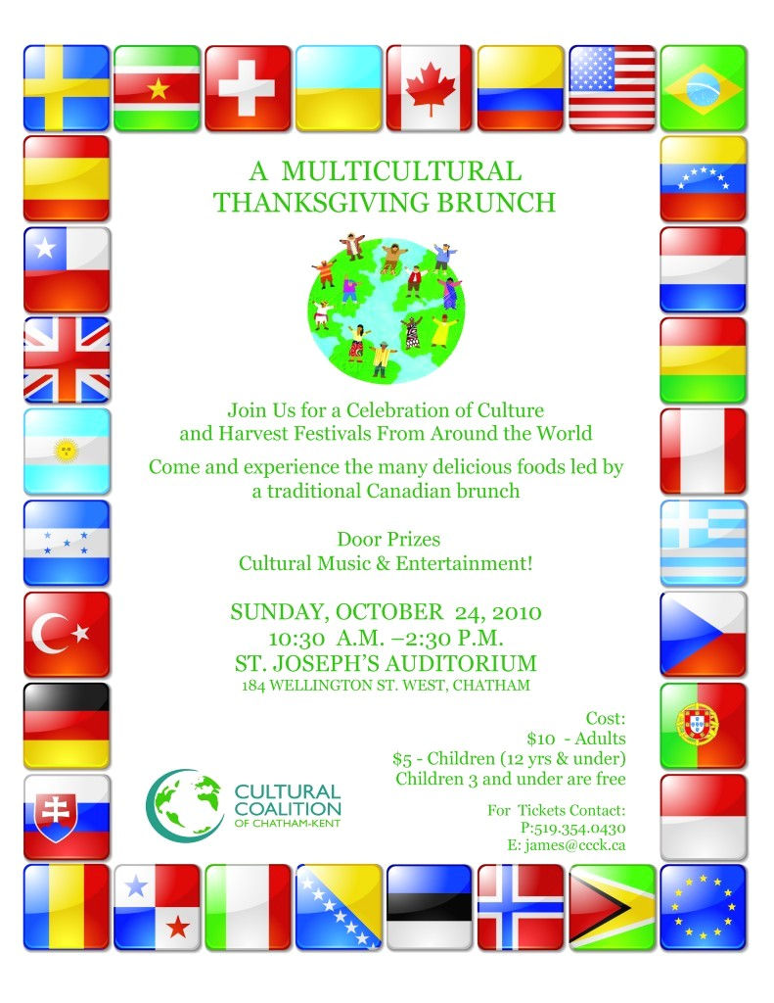

**Harris Creek Elementary Heritage Night**

**Join Us for a Celebration of Cultures from Around the World**

**Harris Creek Chorus will be performing**

**Displays and music from various countries will be represented along with performances from Sri Lanka, Korea, Venezuela, Philippines, and Latin American cultures**

**Food Trucks will be in attendance & Book Fair in the Media Center**

**Thursday, December 6th at 5:30 pm**

Figure 1